I created two new vi’s and they are being called from the teleop vi for testing single and double solenoid. Now that I have them built it looks like one VI could handle both operations.

Telop now looks like:

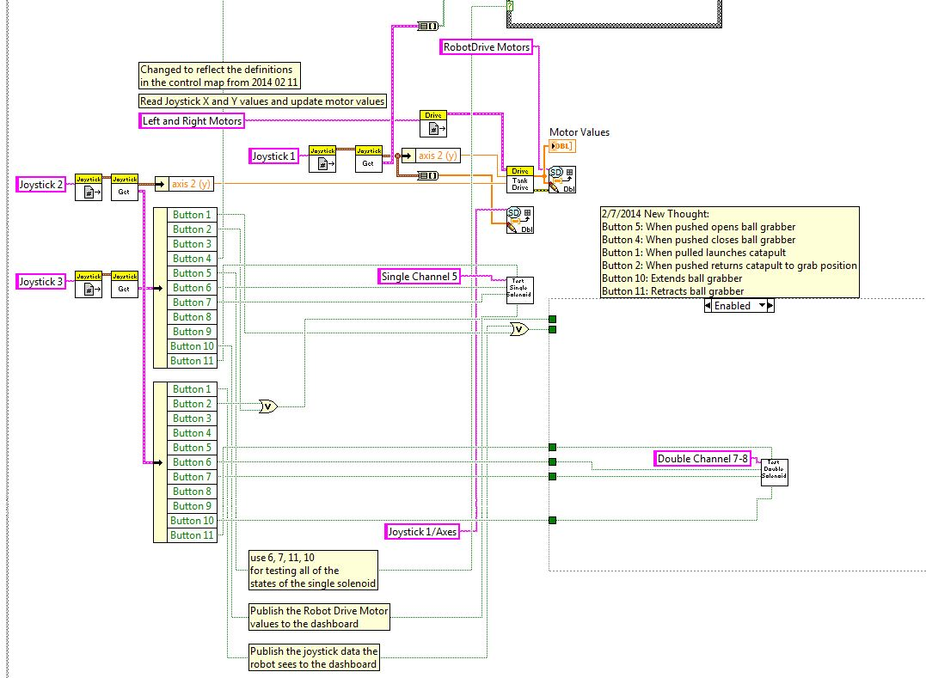

The vi, test single solenoid looks like:

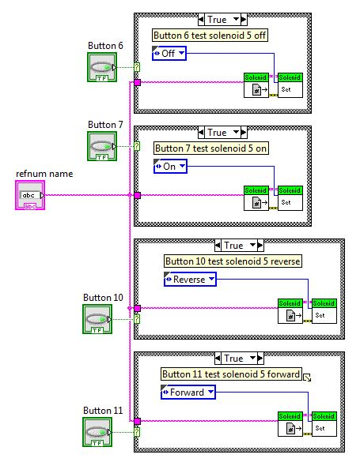

The vi, test double solenoid looks like:

